DEXPI Gap modelling suggestions:

SensorWell:
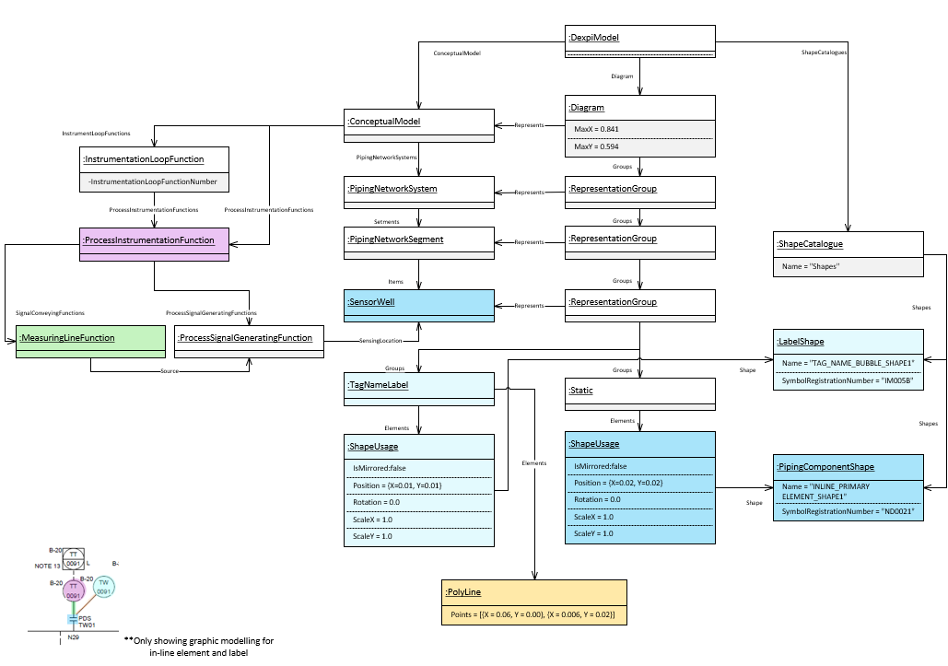

Mounted Sensing Instrument
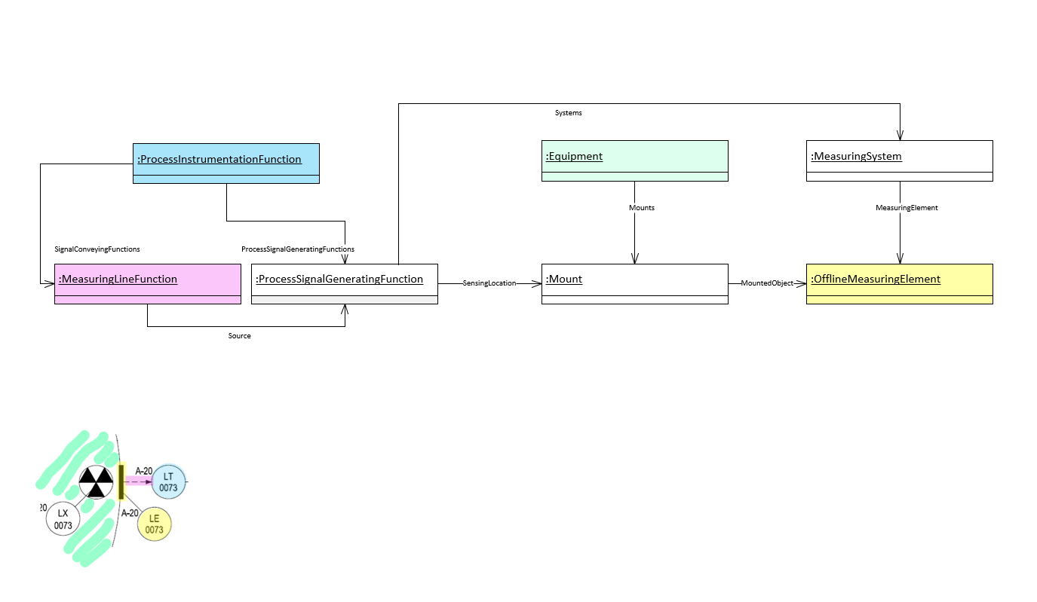
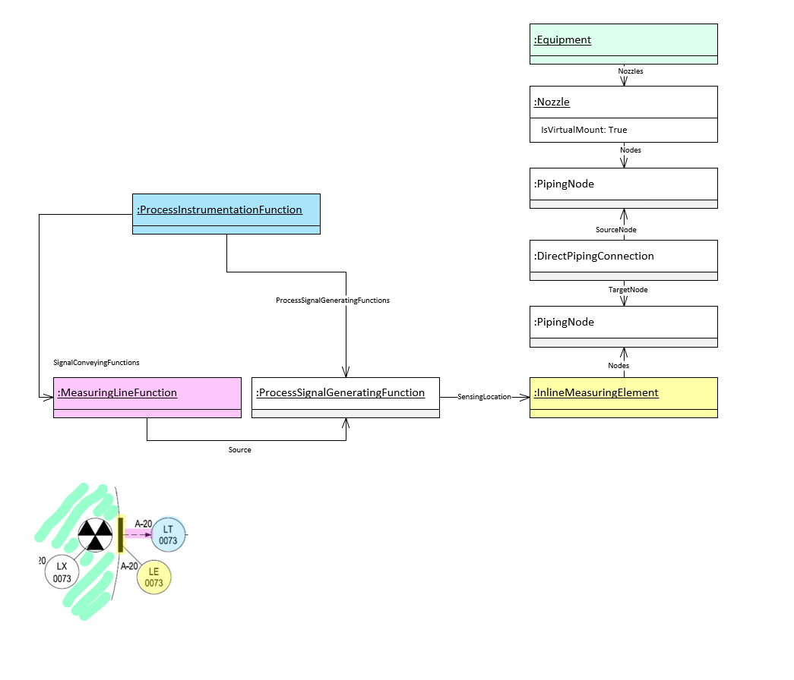

Transmission System:

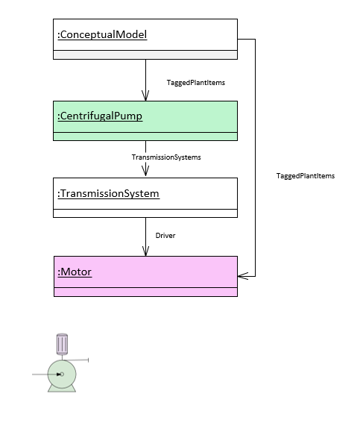

Electrical Energy (Power):

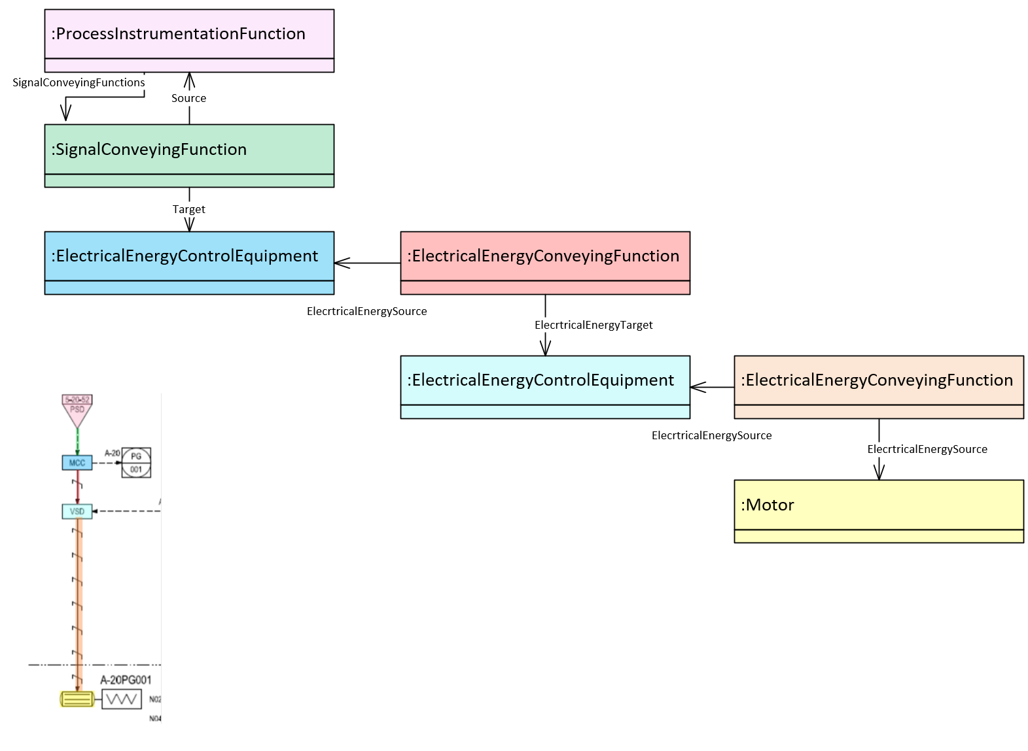
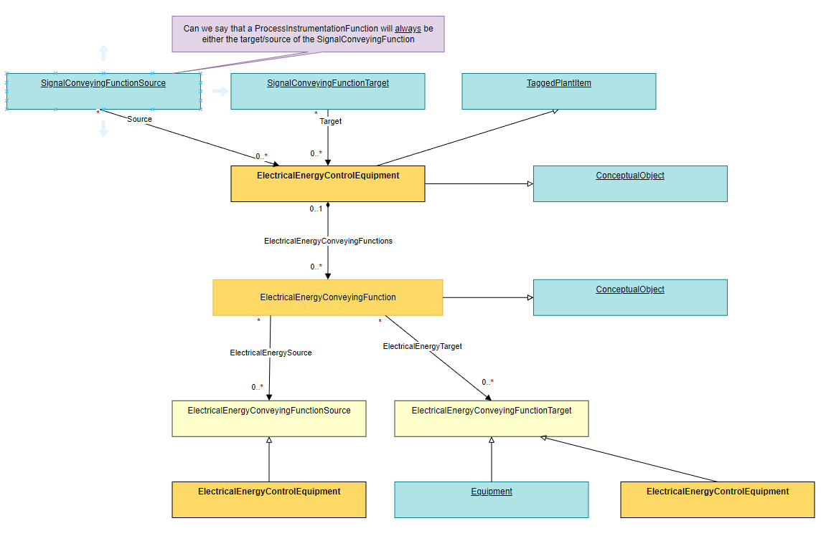

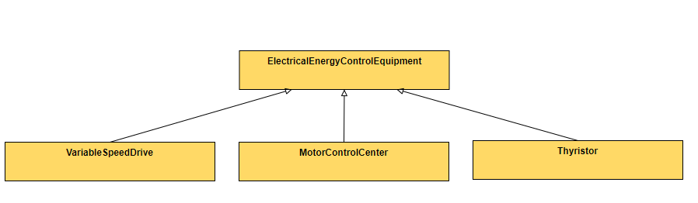

Process Vessel Components:

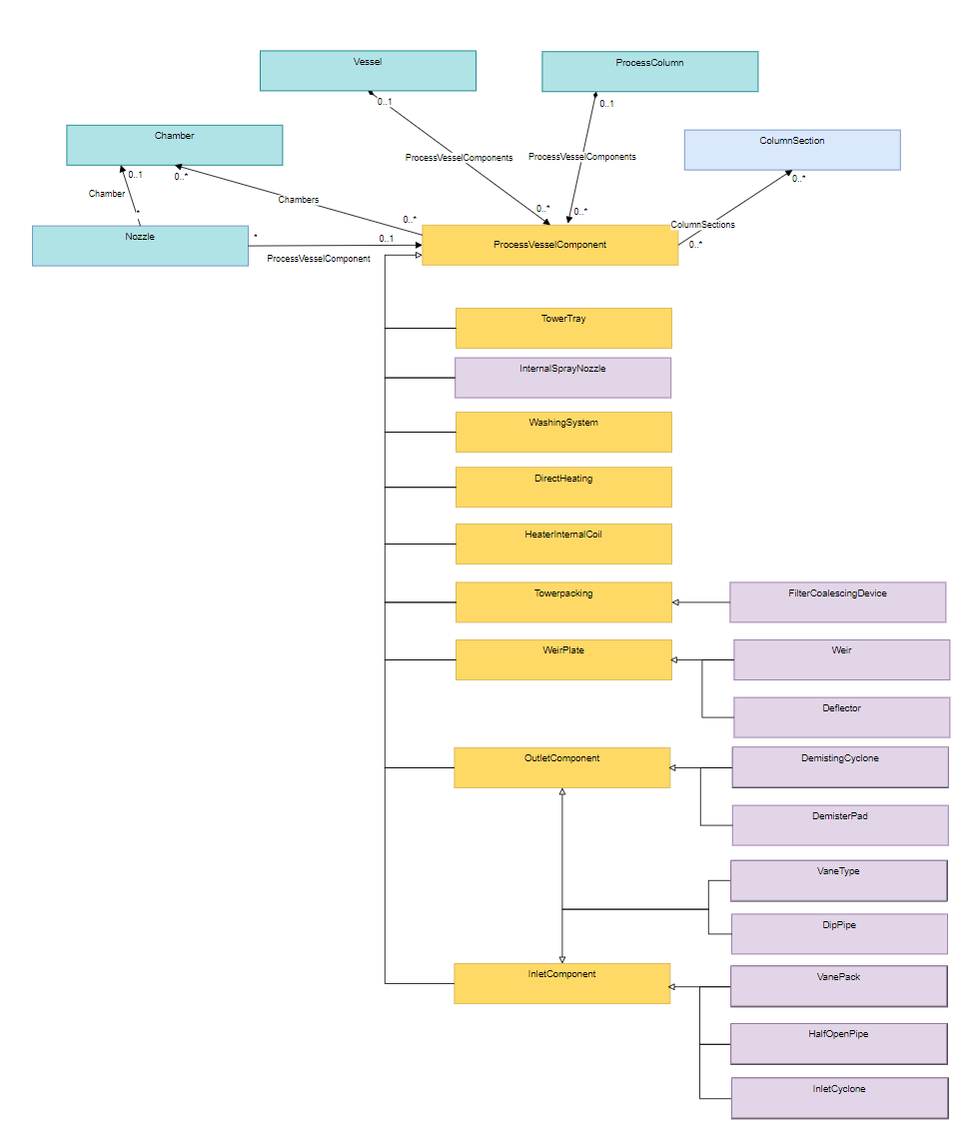

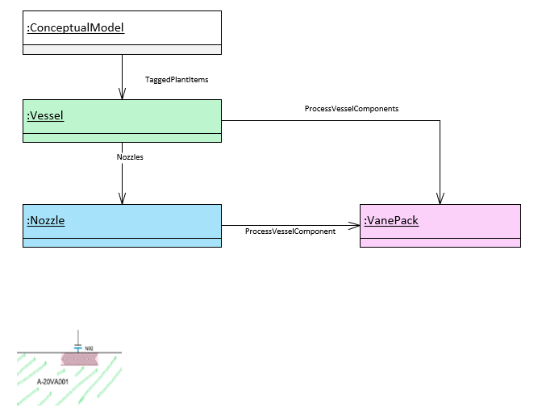

Tie-Ins:
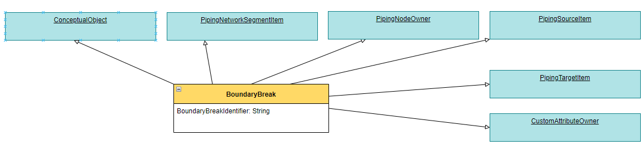

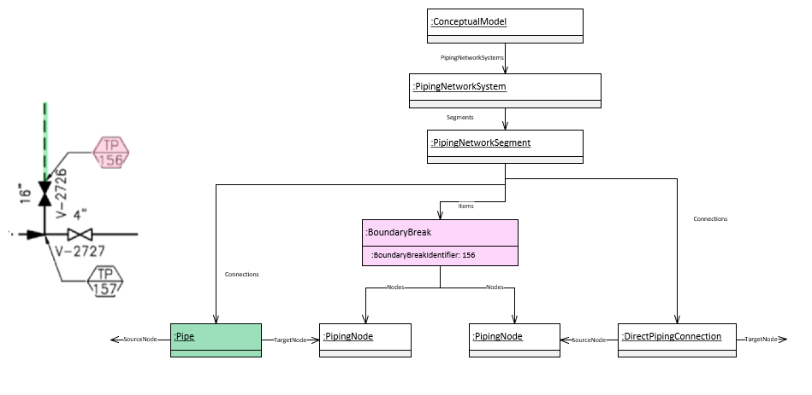

Battery Limit / Vendor Package Boundary:
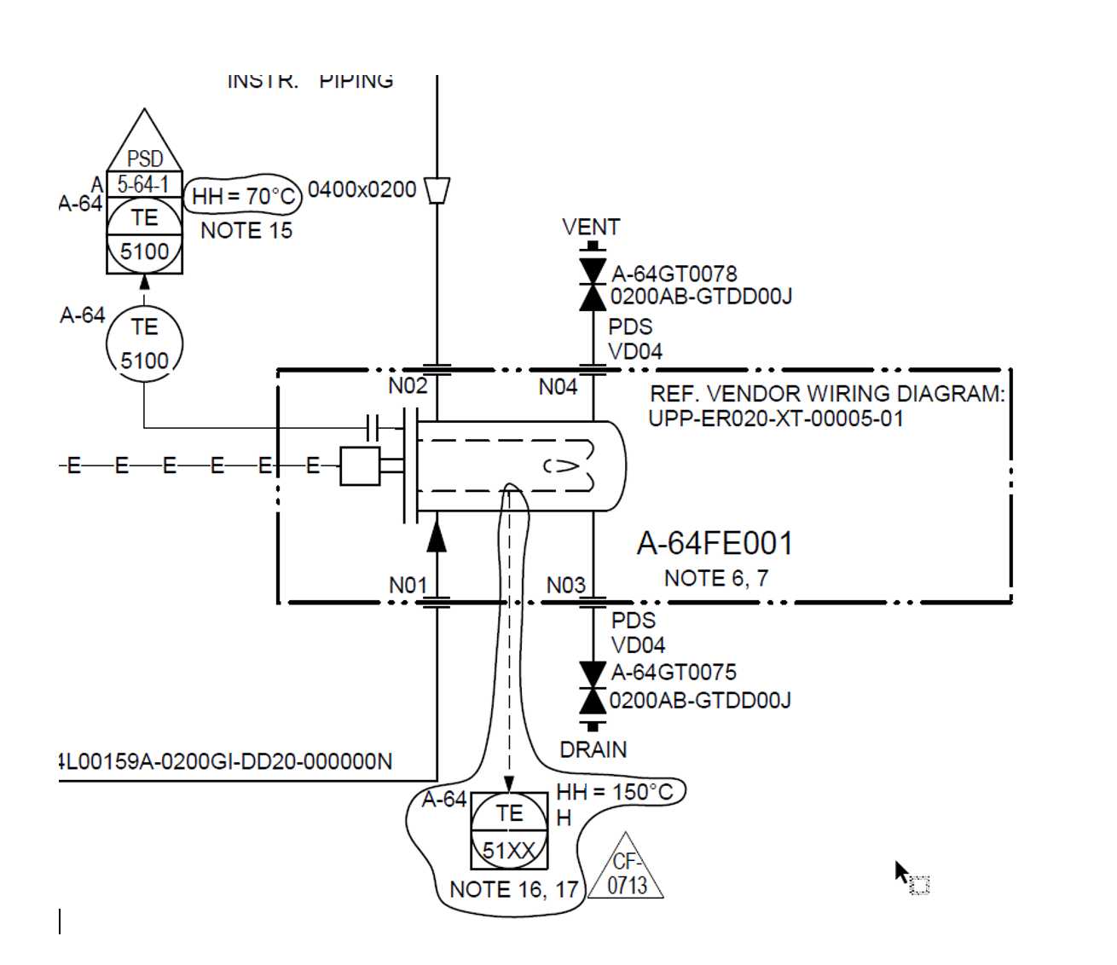
Example showing a package boundary. With dash, dot, dot, dash line…
What information should we capture with this change to the DEXPI information model ?
Boundary points / Grouping towards a package

Signal Conveying Function elements that exist on a drawing without the ‘parent’ ProcessInstrumentationFunction:
What features do we need to address here and how can we solve this. To Discuss.

